Insurance Fraud Claims Detection using Explainable Analytics

Contents
Chapter 3: Methodology 4
3.1 Research Philosophy 4
3.2 Research Approach 5
3.3 Research Strategy 6
3.4 Dataset Collection and Description 6
3.5 Data Preparation and Preprocessing 7
3.6 Class Imbalance Handling 8
3.7 Machine Learning Model Development 8
3.8 Model Evaluation Strategy 9
3.9 Explainable Analytics Framework 10
3.10 Streamlit Dashboard Development 10
3.11 Ethical Considerations 11
References 12

List of Figures

Figure 1: presents the proposed system architecture for the insurance fraud detection framework. 5

Chapter 3: Methodology

3.1 Research Philosophy
The research philosophy that will guide this project is the positivist research philosophy. It implies gathering and analysing objective data with the aim of producing measurable results based on evidence. In fact, a positivist research philosophy is regarded as appropriate for the current project, as the purpose of this study is to detect insurance fraud through the application of quantitative data analysis and machine learning models (Chew et al., 2023). The project uses structured insurance claims records, but not people's perceptions and personal experience; therefore, a data-driven approach would be appropriate for conducting the research. The chosen philosophy provides grounds for utilising statistical approaches, predictive models, and performance indicators to analyse data patterns associated with fraudulently made insurance claims. The efficiency of the selected machine learning models will be measured through quantitative metrics like accuracy, precision, recall, F1-score, and ROC-AUC. Moreover, explainable analytics tools will be used to produce clear explanations of predictions made by the models based on measurable features. Thus, the adoption of the positivist research philosophy will allow the researcher to conduct an objective analysis of data in order to draw conclusions supported by objective evidence.
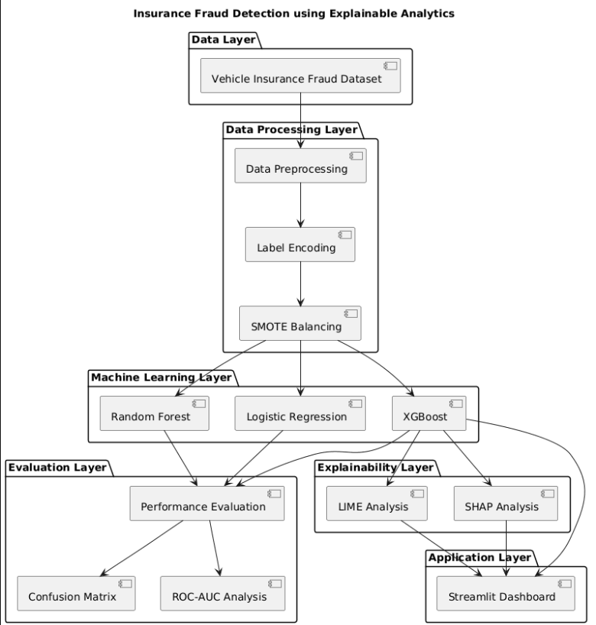
Figure 1: presents the proposed system architecture for the insurance fraud detection framework.

3.2 Research Approach
In this study, the use of machine learning and explainable analytics in insurance fraud detection will be examined using the quantitative research methodology. Quantitative research methodology is considered to be the most suitable due to the nature of the study and the type of data that needs to be analysed. The study will make use of quantifiable information as well as statistical and predictive modelling techniques to come up with objective conclusions. In this case, an existing public dataset of vehicle insurance fraud will be used for the study. First, data preprocessing techniques will be used before developing different models based on machine learning algorithms (Zhao & Bai, 2022). The following algorithms will be compared in terms of performance: Logistic Regression, Random Forest and XGBoost. The performance of models will be evaluated using some quantitative metrics of performance, which include the accuracy, precision, recall, F1 score, and area under the receiver operating characteristic curve (ROC-AUC) (Chew et al., 2023). Moreover, explainable analytics techniques like SHAP and LIME will be included to enhance model performance. The use of a quantitative technique will help in the objectivity of the assessment of the performance of models and come up with evidence-based conclusions.

3.3 Research Strategy
The chosen approach for the current study would involve the implementation of the system development and experimental research approach, which would allow for creating and evaluating a machine learning and explainable analytics-based insurance fraud detection system. This approach seems relevant for the current research since the study focuses not only on analysing insurance claims data but also on creating a tool that could help make decisions regarding detecting fraud in the insurance industry. The current research will start from the acquisition and investigation of a vehicle insurance fraud dataset (Özaltın & Erdemir, 2025). Data will be preprocessed, including such steps as data cleaning, encoding of categorical data, and feature engineering for machine learning modelling. Fraud data sets usually involve an imbalance in class distributions, so specific approaches will be implemented to solve this problem.
After data preparation, several Machine Learning models will be built and trained on the prepared dataset, among which are Logistic Regression, Random Forest, and XGBoost. The performance of each model will be assessed and compared based on standard metrics used for classification tasks. The best-performing model will be chosen for additional study. In order to increase the interpretability of results, explainable analytics will be added to the framework using methods like SHAP and LIME (Ileberi et al., 2022). Finally, the best-performing model and the components of explainability will be included in a Streamlit dashboard, allowing users to interactively explore fraud predictions and explanations of the models.

3.4 Dataset Collection and Description
In this study, the Vehicle Insurance Fraud Detection Data Set will be utilised. The Vehicle Insurance Fraud Detection Data Set has been sourced from Kaggle. This data set has been chosen because it includes real attributes of insurance claims, which can be used in the process of model building for fraud detection. Insurance fraud remains a major problem for insurance companies, and the fact that there is historical information about claims makes it possible to find out fraud patterns using data analysis methods (Khalil, 2025).
https://www.kaggle.com/datasets/shivamb/vehicle-claim-fraud-detection?utm
The provided dataset includes 15,420 records and 33 variables that represent characteristics of clients, cars, accidents, and claims in the field of insurance. These features can include such values as age, gender, category of the car, type of the insurance policy, deductible, accident zone, driving record, and others related to claims. The target feature of this data set is FraudFound, which shows whether claims are fraudulent or not. In other words, the provided labelled dataset can be used for building supervised classification machine learning models. Thus, it contains numerical and categorical data that can be analysed in terms of detecting possible factors affecting fraud detection (Nabrawi & Alanazi, 2023). In addition, the provided dataset is quite big and can be applied for training and testing machine learning models, which allows assessing their performance effectively. Moreover, the data set shows real situations related to insurance claims. Consequently, it is possible to check how machine learning algorithms can detect suspicious claims.

3.5 Data Preparation and Preprocessing
The data will be prepared and preprocessed to ensure that it is suitable for machine learning analysis and model development. Raw sets contain inconsistencies, redundant data, categorical features, and so on that may need transformation before machine learning algorithms can effectively use them. Thus, there will be a structured pre-processing which will provide better data quality and increase the model performance (Fritz-Morgenthal et al., 2022). The first data set will be analysed to determine if there are any missing values, any duplicate records, or any problems with the data quality. Inconsistent records will be checked and dealt with accordingly to ensure the reliability of the analysis. Descriptive statistics and exploratory analysis techniques will also be used to understand better the structure of the data set and distributions of features.
There are a number of categorical variables in the data, so techniques for encoding categorical data will be used to transform categorical data into numbers that can be used for machine learning algorithms. Label Encoding will be used to convert categorical variables like vehicle type, policy type, marital status, accident area, etc. into machine-readable form. Numerical attributes will be examined for consistency and appropriateness for the model training. After data transformation, the target variable will be isolated from the predictor variable(s), and the data will be split into training and testing subsets (Nabrawi & Alanazi, 2023). The training data will be used for model development using machine learning methods, and the testing data will be saved to assess the models' performance in an unbiased way. This pre-processing step will build a tidied and organised dataset that will facilitate accurate fraud prediction and correct model evaluation during the study.

3.6 Class Imbalance Handling
Dealing with the class imbalance problem is one of the major challenges in the task of detecting insurance fraud. The imbalance is caused by the fact that in real-life insurance data, the number of legitimate claims considerably outnumbers the number of fraudulent ones. As a result, the machine learning models may be biased towards the majority class, which adversely affects the detection of fraud. In such situations, the use of accuracy for the performance evaluation of the algorithms produces erroneous results. In order to solve this problem, the Synthetic Minority Oversampling Technique (SMOTE) will be used for the data preparation (Btoush et al., 2023). SMOTE is a popular resampling technique that creates synthetic samples of the minority class and does not simply copy the existing examples. By generating extra synthetic examples of the fraud, SMOTE equalises the distribution of classes within the training set. The application of SMOTE is supposed to increase the ability of the machine learning algorithm to detect fraud and decrease the bias towards legitimate claims.

3.7 Machine Learning Model Development
The major objective of this research work is the development of an efficient machine learning-based system for the identification of fraud in insurance claims. In this respect, various classification algorithms will be considered and examined with regard to their applicability to detect fraud. The use of different models will allow for comparing the efficiency of predictions and gaining insights about the advantages and disadvantages of different machine learning approaches. Three supervised machine learning algorithms are chosen for this research: Logistic Regression, Random Forest, and XGBoost. The first one will be used as a simple and efficient classification model to act as a conventional benchmark to evaluate the efficiency of other models. Random Forest will be used as an ensemble learning technique, which combines several decision trees to improve the accuracy of predictions and prevent overfitting (Ti et al., 2022). This algorithm is efficient in dealing with complex relations in data and has been successfully used in different fraud detection tasks. Its ability to identify the importance of features is another useful attribute.
The chosen advanced machine learning algorithm for this research is XGBoost (Extreme Gradient Boosting). This machine learning algorithm has been proven to have superior predictive accuracy, computational performance, and the capability to work with structured tabular data. The algorithm uses the concept of gradient boosting to improve the model through each iteration by fixing the mistakes made in the previous iterations. Since this algorithm has been proven to perform effectively in classification tasks, it can be assumed that it would perform well in the fraud detection task. First, the data set will be split into training and test sets before model building. The algorithms will be trained using the processed training data and tested on unseen test data. Comparison between the two algorithms will be done using accuracy, precision, recall, F1 score, and ROC-AUC metrics.

3.8 Model Evaluation Strategy
The performance of the designed machine learning models will be assessed using an extensive evaluation method. Since detecting insurance fraud is a binary classification task, several measures will be used to provide a fair evaluation of the predictive ability of each model. The use of accuracy alone is not an ideal approach in evaluating the performance of a model when working with fraud data, where there is usually an imbalanced distribution of classes, and legitimate cases are more than those labelled as fraud. Accuracy will be used to measure how many of the predictions made are correct (Zhao & Bai, 2022). Additionally, other measures like precision, recall, and F1-score will be considered. Precision will be used to measure the percentage of predicted cases that are indeed fraudulent, while recall will be used to evaluate the ability of the model to detect fraudulent cases. Recall is very important in fraud detection since failing to detect fraudulent cases might cost insurance companies money.
Moreover, the Receiver Operating Characteristic Area Under the Curve (ROC-AUC) method will be used to measure the ability of the model to classify fraud cases as well as non-fraud cases using different classification thresholds. A higher ROC-AUC score means better classification. In addition to numerical values, Confusion Matrices will be plotted to represent the classification results and to count the number of true positives, true negatives, false positives, and false negatives obtained using each model. Comparison of the results of the evaluation process systematically will help in finding out the best machine learning algorithm for insurance fraud detection.

3.9 Explainable Analytics Framework
The major issue with machine learning-based fraud detection is the lack of clarity when it comes to the reasoning process of the algorithm. While advanced algorithms may have great predictive power, they are often used as “black box” models, which do not allow users to understand the logic of the particular predictions. In the context of the insurance industry, explainability is especially important since any decision made in connection with fraud may have significant financial and organisational implications (Ali, 2022). Therefore, the proposed study will incorporate explainable analytics in order to improve the model interpretability. SHAP (SHapley Additive exPlanations) will be used as the main method of explanation in this research. SHAP is a game theory framework that explains how individual features impact the model’s output, thus allowing researchers to get both local and global explanations. Using this methodology, we will be able to identify the most influential features that affect the fraud detection process as a whole and for particular insurance claims.
Further, LIME (Local Interpretable Model-Agnostic Explanations) will be used to provide local explanations for individual predictions. The basis of LIME is to approximate the behaviour of a complex model around a specific instance and find the features that have the largest effect on the prediction result. This will enable users to know why a specific claim is identified as fraudulent or real (Khalil, 2025). The research will integrate SHAP and LIME to offer a global and local interpretation. These explainability methods will contribute to a more transparent and trustworthy utilisation of machine learning models within insurance fraud detection systems, paving the way for their practical application.

3.10 Streamlit Dashboard Development
A web-based dashboard will be created utilising Streamlit to make the proposed fraud detection system more user-friendly and accessible. Streamlit is an open-source Python-based framework that can be used to quickly build interactive data science and machine learning apps. It has been chosen for this research for its simplicity, flexibility and ease of integration of machine learning models in intuitive interfaces, without needing to have a lot of expertise in web development. The dashboard will be the front-end of the proposed system and will give an interactive space for exploring insurance fraud predictions and model explanations. The user will be able to enter relevant data related to an insurance claim, and a prediction will be made as to whether the claim is fraudulent or not. This functionality will showcase how the machine learning model can be used in practice.
The dashboard will also feature a capability for exploring the data and assessing model performance, in addition to fraud prediction. Evaluation results will be shown in a clear and understandable format using visualisations (confusion matrices, model comparison charts, performance metrics). In addition, the dashboard will include explanations from model outputs produced by SHAP and LIME to give clear insights into the model's decision-making process. This Streamlit dashboard will serve as a proof-of-concept application to illustrate that machine learning and explainable analytics can be integrated into a viable fraud detection system. The dashboard will be intuitive and easy to use, allowing users to understand better, interpret, and share fraud prediction results.

3.11 Ethical Considerations
Ethical issues are crucial to ensure that the research is carried out ethically and professionally. In this study, no direct contact with human subjects is required because they will be using a publicly available insurance fraud dataset from Kaggle. As a result, the research will not require surveys, interviews, observation or collection of personal data from persons. The data set will be used only for academic research and will be processed according to the conditions and terms of the data supplier. The personally identifiable information found in the data set will not be released or used for purposes other than those of this study. Moreover, research to develop and test machine learning models will be based on the principle of non-harm to individuals, organisations and society. The proposed fraud detection system will be developed as a decision support system and not as a fully automatic decision-making system. Explainable analytics techniques will be integrated in order to increase transparency and lower the risks of black-box machine learning models. These measures will ensure that the research is carried out in an ethical, responsible manner and in accordance with the academic guidelines.

References
Ali, A. (2022). Financial Fraud Detection Based on Machine Learning: A Systematic Literature Review. Applied Sciences, [online] 12(19). doi: https://doi.org/10.3390/app12199637.
Btoush, E.A.L.M., Zhou, X., Gururajan, R., Chan, K.C., Genrich, R. and Sankaran, P. (2023). A systematic review of the literature on credit card cyber fraud detection using machine and deep learning. PeerJ Computer Science, 9, p.e1278. doi: https://doi.org/10.7717/peerj-cs.1278.
Chew, P., Yang, Y. and Lee, B.-G. (2023). Enhancing Financial Fraud Detection through Addressing Class Imbalance Using Hybrid SMOTE-GAN Techniques. International Journal of Financial Studies, 11(3), pp.110–110. doi: https://doi.org/10.3390/ijfs11030110.
Fritz-Morgenthal, S., Hein, B. and Papenbrock, J. (2022). Financial Risk Management and Explainable, Trustworthy, Responsible AI. Frontiers in Artificial Intelligence, 5(1). doi: https://doi.org/10.3389/frai.2022.779799.
Ileberi, E., Sun, Y. and Wang, Z. (2022). A machine learning based credit card fraud detection using the GA algorithm for feature selection. Journal of Big Data, [online] 9(1). doi: https://doi.org/10.1186/s40537-022-00573-8.
Khalil, A.A. (2025). Enhancing Insurance Fraud Detection Accuracy with Integrated Machine Learning and Statistical Methods. Computational Economics. doi: https://doi.org/10.1007/s10614-025-11074-0.
Nabrawi, E. and Alanazi, A. (2023). Fraud Detection in Healthcare Insurance Claims Using Machine Learning. Risks, [online] 11(9), p.160. doi: https://doi.org/10.3390/risks11090160.
Özaltın, Ö. and Erdemir, Ö.K. (2025). Detecting automobile insurance fraud using a novel penalty-driven feature selection method with particle swarm optimisation and machine learning classifiers. Scientific Reports, [online] 15(1). doi: https://doi.org/10.1038/s41598-025-25700-2.
Ti, Y.-W., Hsin, Y.-Y., Dai, T.-S., Huang, M.-C. and Liu, L.-C. (2022). Feature generation and contribution comparison for electronic fraud detection. Scientific Reports, [online] 12(1), p.18042. doi: https://doi.org/10.1038/s41598-022-22130-2.
Zhao, Z. and Bai, T. (2022). Financial Fraud Detection and Prediction in Listed Companies Using SMOTE and Machine Learning Algorithms. Entropy, 24(8), p.1157. doi: https://doi.org/10.3390/e24081157.

